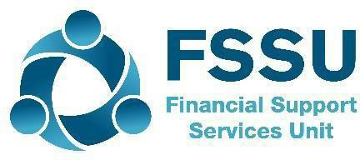


BrightBooks Accounts
Monthly BOM Reporting

Building confidence & forming good review habits
Practical suggestions for reviewing BrightBooks reports for accuracy
1. Review the Income & Expenditure Account
This takes time and experience
- Compare to budget figures – important to have the budget figures in the accounts
- Compare to Prior Year to date
- General ledger Chart of accounts – lookup and review for errors & Amend postings if necessary
- Ensure that grants due & grants received in advance are correctly adjusted for at 1.9.2024
2. Review the Balance sheet balances
Completeness and accuracy check
- Bank Balances should agree to Bank rec reports
- Ensure necessary journals @ 1.9.2024 are recorded in BrightBooks
- Important to have a breakdown of the balances in codes 2105 & 2150
- Check that the balance sheet balances are accurate at month end
3. Reviewing the bank rec reports for accuracy
Accuracy checks on the accounts:
- Adjust old unreconciled payments
- Follow up Unreconciled receipts – duplicates overstate income
- Make any adjustments required
4. Reviewing the Purchase ledger list for accuracy
- Reconcile balances to supplier statements
- Follow up and adjust for Duplicate invoices
- Follow up Debit balances – verify and post invoices to record cost
5. Review the Department reports to monitor the Grant spends year to date
- Junior Cycle free books grant
- NTPG
- Capital & ICT Grants
6. Review with principal and make amendments
After this review – ready to run a draft set of BOM reports for review with Principal
Have a General Ledger activity report for the reporting period.
7. Distribute and file a full set of BOM reports monthly
Run the Simple Trial balance and data check
Run & file final BOM reports, cross check reports and distribute to SFC three days before meeting

