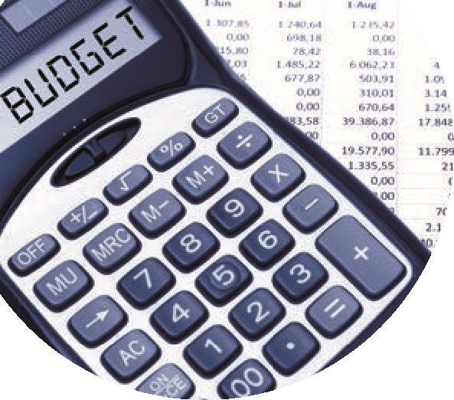

**Preparing for the Accountant**

|  |  |  |  |
| --- | --- | --- | --- |
|  |  |  |  |
|  | Finalising Draft Year end accounts | Points to note |  |
| 1 | Review the draft accounts for Year-end Aug 2024 |  |  |
|  |  |  |  |
| 2 | Distribute the August BOM reports to the BOM | Cross check reports |  |
|  |  |  |  |
| 3 | Housekeeping in Sage 50 Accounts |  |  |
|  | * Check Financial Year in Sage 50 | Settings / Financial Year |  |
|  | * It should be starting September 2023 |  |  |
|  | * Is the Trial Balance brought forward agreeing to the annual accounts? | Email Trial Balance to Accountant if not and ask for adjustments |  |
| 4 | Contact Accountant | Early contact will help to get the work in motion |  |
|  | Give Accountant remote data access to Sage 5O dataset |  |  |
|  | Ask for details of Year end visit and a list of what they will need |  |  |
| 5 | September 30th – Deadline for submission of accounts to Accountant |  |  |
| 6 | Year-end adjustments required from Accountant by Oct 28th 2024 | Record adjustments if available |  |
| 7 | October 31st 2024  Deadline for running Year end in Sage 50.  Balance sheet balances can be adjusted after this point | Process Year end in Sage 50  Import the 24/25 Budget  Ready to Run BOM reports for new Financial Year |  |
| 8 | Check Financial Year in Sage 50  It should be starting September 2024 | Settings / Financial Year |  |

**Financial Accounts 2023/2024**