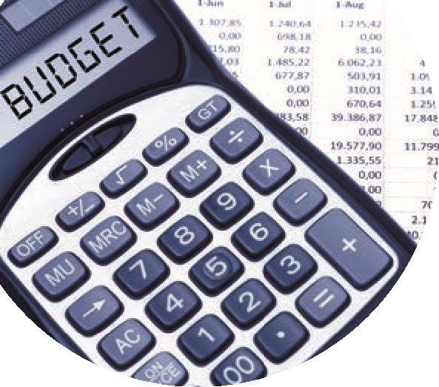
BOM Monthly Reports from Sage 50 Accounts
Final accuracy checklist
 | Month end reports | Comments | Month:  Checked
1 | A list of balances on all school bank and cash accounts | Run from the print list in the Bank module. The bank balance showing here is always the latest bank balance at time of printing. | Jan 2024
2 | Bank reconciliation report for all school bank accounts | Check that the Cashbook balance in this report agrees to the relevant bank balance in the Balance sheet  Outstanding items reviewed for accuracy. Duplicates or errors are corrected | Jan 2024
3 | Income & Expenditure report | The final net profit/loss should agree to the Income & expenditure figure showing at the end of the Capital & Reserves section in the Balance Sheet | Jan 2024
4 | Balance sheet report from B/F | Cumulative balances to the month end being reported on.  The bank rec reports and the Aged Creditor balances should also be generated to this same month end date and balances should always be cross checked | Jan 2024
5 | List of Supplier balances | The total of this list should agree to the balance in code 2100 in the Balance sheet at the month end | Jan 2024
6 | List of Accruals/Income in advance/prepayments | Department report for Income in advance and total to agree to balance in code 2105.  Listing of prepayments agreed to balance in code 1720.  Listing of accruals agreed to balance in code 2440. | Jan 2024
7 | Capital Income & Expenditure account report (if applicable). | Info generated from a department report from Sage which analyses the movement on the various nominal accounts | Jan 2024

