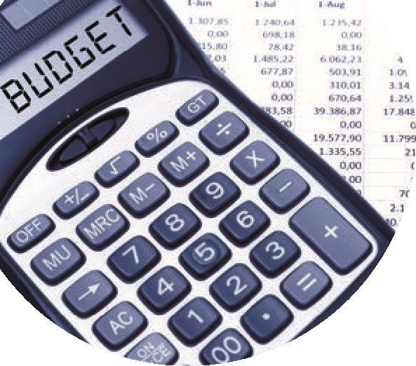

Managing a Capital project
Using a Suppliers ledger in Sage 50
 | Task | Sage 50 Accounts preparation | Available resources
 | Work with the project management team | - Gather all project information  - DE remittance & project costs  - Budget information for template  - Check Chart of account codes – (contribution to Fixed Asset Codes) in Sage 50 | Template to assist with  reporting on Capital  Project  Supplier App Form
 | Register contract in ROS
 |  | - Create a department in Sage 50 for the Cap Project which includes an add documents feature.
 |  | - Record DE Grant in Sage 50 (Use Dept)
 | Relevant Contract Invoice | - Record purchase invoice in supplier ledger using the Dept reference
 |  | - Record VAT Journal in Sage 50
 |  | - Record a supplier credit note to reflect the RCT in code 2270 if applicable
 |  | - Request a Supplier statement and reconcile balance to supplier ledger balance
 | Notify payment to Revenue
 | Making payment to Supplier | - Record supplier payment in suppliers ledger in Sage 50 using Bank Payment
 | VAT Return | Record VAT Payment in VAT control account in Sage 50
 | RCT Return | Record RCT payment in RCT Control account in Sage 50 using Bank Payment
 | Regular monthly reporting from Sage 50 | - Review nominal activity to check for accuracy of recording
 | Cap Project reporting template | - Run department report to monitor & report on the capital Project

